

**Brief Introduction**

In this article I will be highlighting my journey of learning and building Machine Learning models.

I have choosen to share my experience for **Customer Churn Analysis Project where I will be highlighting my findings and my experience and the ability to observe patterns and how to find key story behind the data.**

So, without any further delay please allow me to explain the agenda for this blog post. In this article,I have jotted down all the techniques in the form of sub-topics that I will be explaining one by one. And those pointers are as follows:

1.      Problem Definition  
2.      Data Analysis  
3.      EDA  
4.      Pre-processing Data  
5.      Building Machine Learning Models  
6.     Concluding Remarks

**Problem Definition**

**This Project lays down emphasis on keeping the existing customers it has been studied and proven that keeping and cross selling the products to existing customers is much beneficial for the companies** and keeping this in view a telecom company has identified the base of prime features which can be useful to identify the patterns and different aspects where customers are choosing churns.

Customer churn is one of the most important metrics for a growing business to evaluate. While it's not the happiest measure, it's a number that can give your company the hard truth about its customer retention.

In service industry I have find out some major reasons for churn of customers-

* Service quality.
* Availability of features and content.
* Lower cost substitutes from competitors.
* Negative customer service experiences.

Customer retention can be achieved with good customer service and products. But the most effective way for a company to prevent attrition of customers is to truly know them. The vast volumes of data collected about customers can be used to build churn prediction models. Knowing who is most likely to defect means that a company can prioritise focused marketing efforts on that subset of their customer base.

Preventing customer churn is critically important to the telecommunications sector, as the barriers to entry for switching services are so low.

Therefore the major goal of this project is to identify the “Churn” rate as a simple Yes or a No tag making this to be a classification problem!

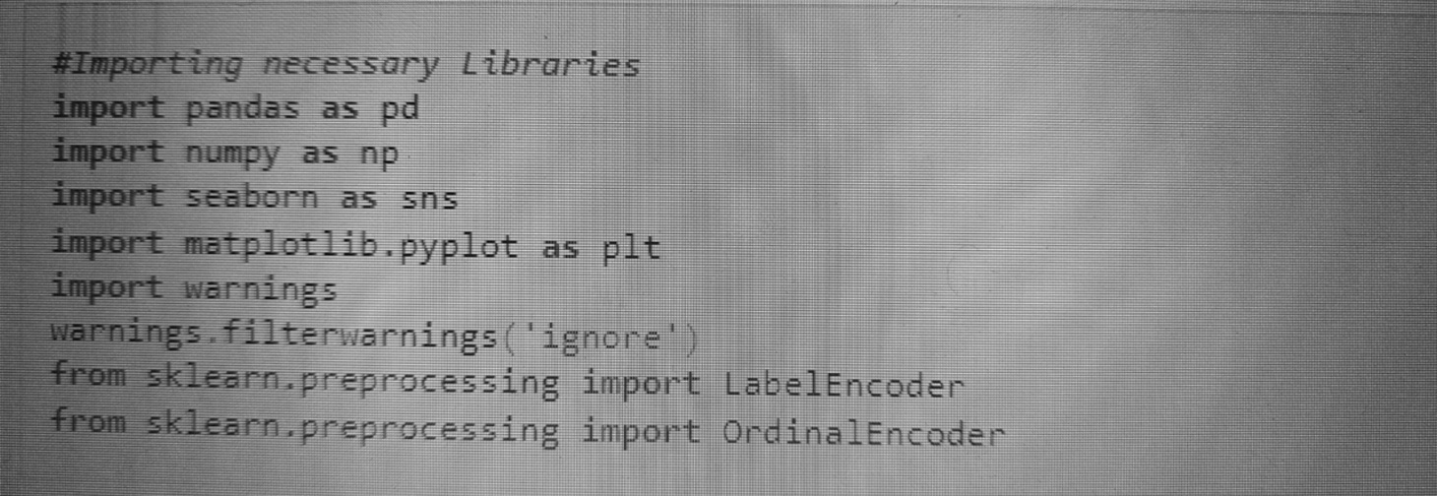First we are going to import all the necessary dependencies here that will be used in our project and obtain the rest as and when required. Before we begin with any process, we need to get the dataset in our Jupyter Notebook that can be achieved by a single step by using beautiful Pandas Library in python.

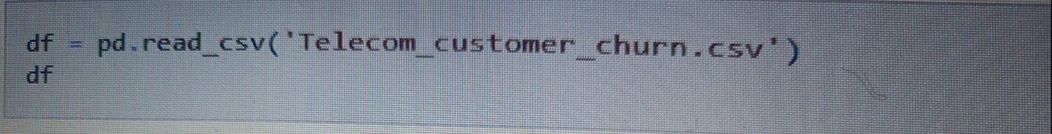

This gives us our entire dataset stored in the variable name “df” for our dataframe.

**2.      Data Analysis**  
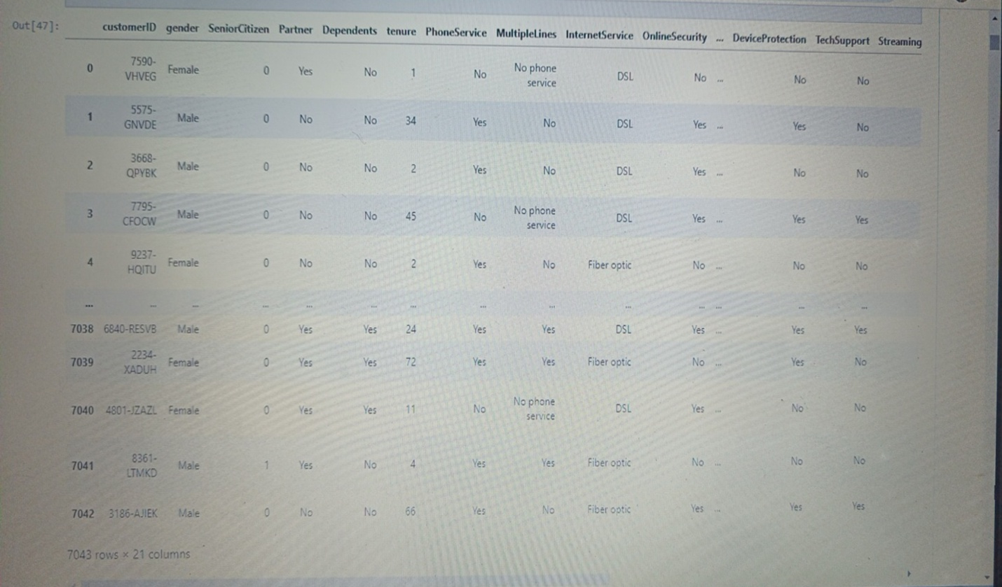  
For data analysis part we can simply eye ball the contents for our dataset trying to make sense of some columns, it’s related values and anything that comes to your mind

In the above line of code we can see that the total number of rows present in our data is 7043 and the total number of columns are 21.

**3.      EDA**

EDA also known as Exploratory Data Analysis is considered the most important aspect in Data Science by many Data Scientist including me. After following a huge number of expert Data Scientist on various platforms I can confirm one thing that it boils down to a single important thing of conveying a story on how you were able to achieve each and every step via your code showing the provided problem statement, the observation, the challenges faced and what was done to tackle or rectify those issues.  
  
Building a good model comes only when you understand clearly what you are doing and why you are doing it. Making sure that you have a clean data in proper processed format to feed into your model and get appropriate result. Because no amount of Machine Learning model usage and hyper parameter tuning is going to help if you have not invested time to sort out and fix your data that’s the only input you have at hand.  
  
There is this famous saying amongst Data Scientist and also people who work with data that goes something like “Garbage in Garbage out” simply translating to mean, if you are trying to build an automated model or make sense out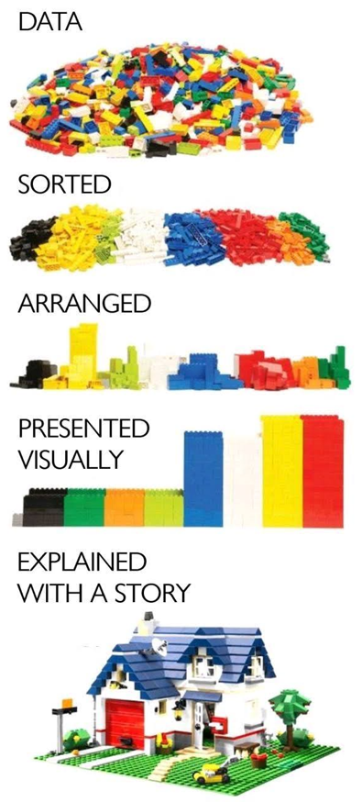 of data that you have you need to clean it and work on it thoroughly before you even start utilizing it further. I cannot stress enough on the process of clean data collection than anything but in real world there is no such thing as clean data. That’s where data analysis comes into picture and using multiple methods from data cleaning to data pre-processingand then data engineering brings us closer to get our desired label prediction.

Enough of the story telling let me show you the code since talk is cheap, but also necessary at times to explain what really is going on. The first thing I am going to take a look at is the missing data information in our dataset by using the codes below.  
  
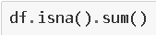

By using this code,we have found there are no null values present in our Dataset and straight forward we moved to check if their are any duplicate values present in dataset.

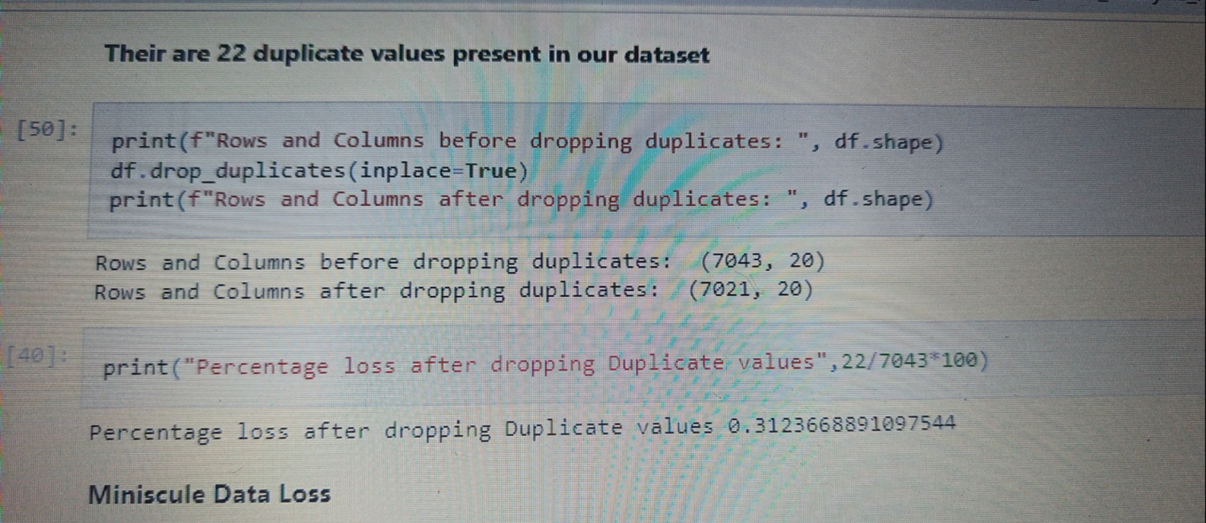

With the `drop_duplicates` option I was trying to get rid of all the duplicate data present in our dataset. However, we can see that there are no duplicate data existing in our dataset.Next, we move on to using the describe method to take a look at the count value, mean data, standard deviation information and the minimum, maximum, 25% quartile, 50% quartile and 75% quartile details. As the describe method works best for numeric data all the object (text) type data gets ignored. Take a look at the below code and you will get an idea on how to use it.  
  
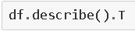

One of the things that I like to do is separate the object datatype and numeric datatype values that allows for easier processing in further steps. The code to do that is a simple for loop usage.  
  
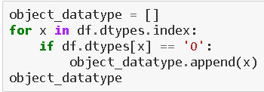

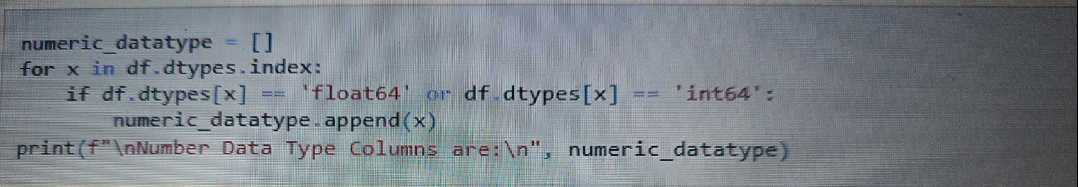

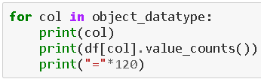

These line of codes provide us the output where we get an entire list of column names with unique datacovered in the dataset rows providing a numerical data and then a description of those values for categorical object datatype columns.  
  
Considering the separation of object data I then take a visual on how many rows or count of rows these values cover in our data set. Usage of various visualization techniques allows me to optimize and analyse the columns further. It gives me an idea as to where data pre processing will be needed and where removal of those data will benefit. Honestly all this can only be acquired from practising on different projects and as everyone.

**We have noticed that Total Charges column has not been included in Numeric Data type where we are trying to convert the same in float but it is showing errors their might be possibility their are blank spaces in same**

**we are Replacing the spaces and values**

**Class Imbalance has been observed in Target Variable**

In [53]:

*df['TotalCharges']* ***=*** *df['TotalCharges']****.****replace(' ' , '0.0')*

*df['TotalCharges']****.****value_counts()*

*df['TotalCharges']* ***=*** *df['TotalCharges']****.****astype('float')*

*numeric_datatype* ***=*** *[]*

***for*** *x* ***in*** *df****.****dtypes****.****index:*

***if*** *df****.****dtypes[x]* ***==*** *'float64'* ***or*** *df****.****dtypes[x]* ***==*** *'int64':*

*numeric_datatype****.****append(x)*

*print(f"\nNumber Data Type Columns are:\n", numeric_datatype)*

*Number Data Type Columns are:*

*['tenure', 'MonthlyCharges', 'TotalCharges']*

**We have succesfully replaced the values**

**we are satisfied to proceed**

After visualizing the count of Object Datatype columns and writing my findings,we checked the distribution for data for our numeric datatype columns

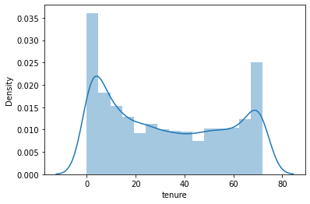

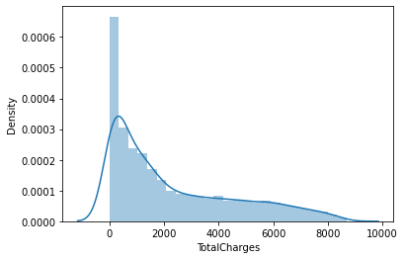

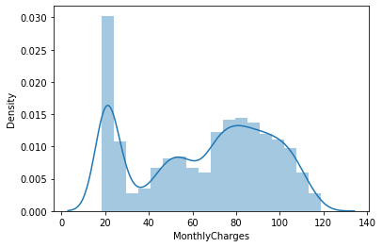

***We have also used Boxplot to visualize outliers and no outliers were observed.***

**4.      Pre-processing Data**  
  
In the pre-processing step I am going to tackle all the miss fits and fix them one by one starting with the problem that out dataset has object datatype values where as our Machine Learning models can only understand numeric values. I am making use of the encoding methods to convert all the object datatype values. For our label I am using Label Encoder while for other categorical feature columns I am using the Ordinal Encoder. Instead of the Ordinal Encoder I could have used The One Hot Encoder but as I mentioned it is all about preference with trial and errors. The One Hot Encoder method increases the number columns while application of Ordinal Encoder on data values offering an order deems a better option to me. I have also seen many people apply Label Encoder on feature columns as well and it does not make any sense to me since the name itself says Label Encoder how much of a specification is required to understand that it is only for our label(s) columns.Hope my readers won’t make the same mistake!

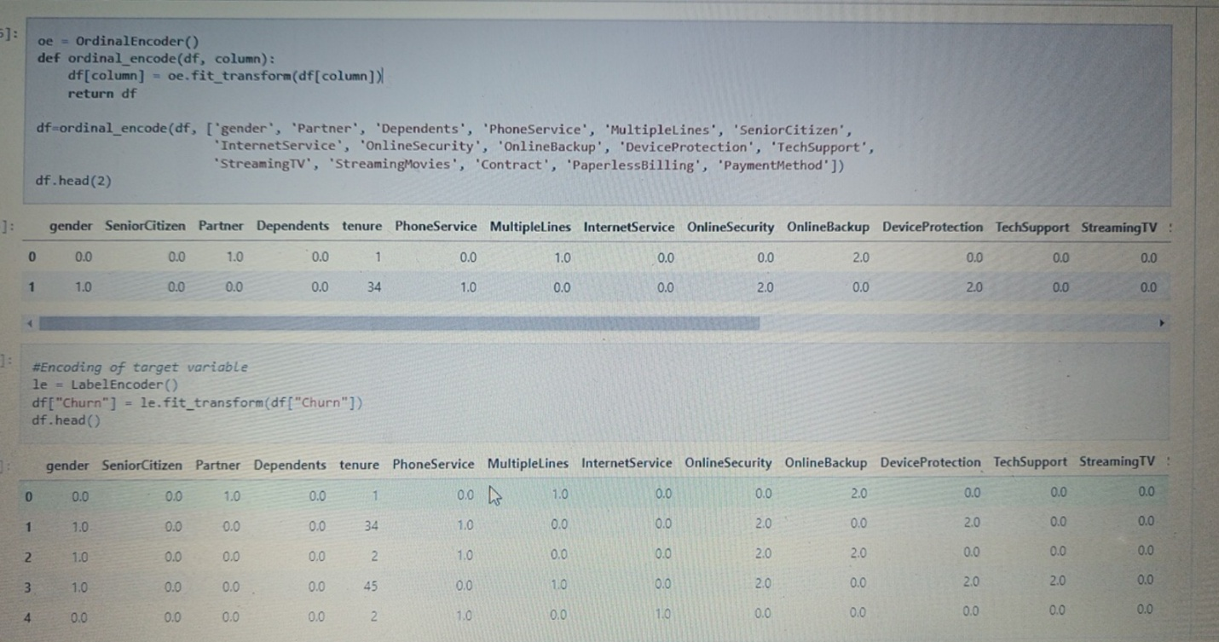

After I have encoded all the columns in our dataset, I am using a Histogram to view the data distribution. Since Histograms only consider numeric data it should be able to identify all the information from our encoded dataframe.

I now feel the need to check for correlation details in our dataset through a Heatmap. For those who still feel a confusion on correlation details let me break it down in two simple points that there are Positive correlation - A correlation of +1 indicates a perfect positive correlation, meaning that both variables move in the same direction together and Negative correlation - A correlation of –1 indicates a perfect negative correlation, meaning that as one variable goes up, the other goes down. The code to see this information is displayed below in second figure,

Here we need to seprate Target and Features

x**=** df**.**drop(columns**=**['Churn'])

y **=** df['Churn']

**Multi-Collinearity check**

*coreleation****=*** *x****.****corr()*

*plt****.****figure(figsize****=****(15,12))*

*plt****.****title("Multi-Collinearity check using Heat Map")*

*sns****.****heatmap(coreleation,cbar****=True****,annot****=True****,cmap****=*** *'coolwarm')*

*plt****.****show()*

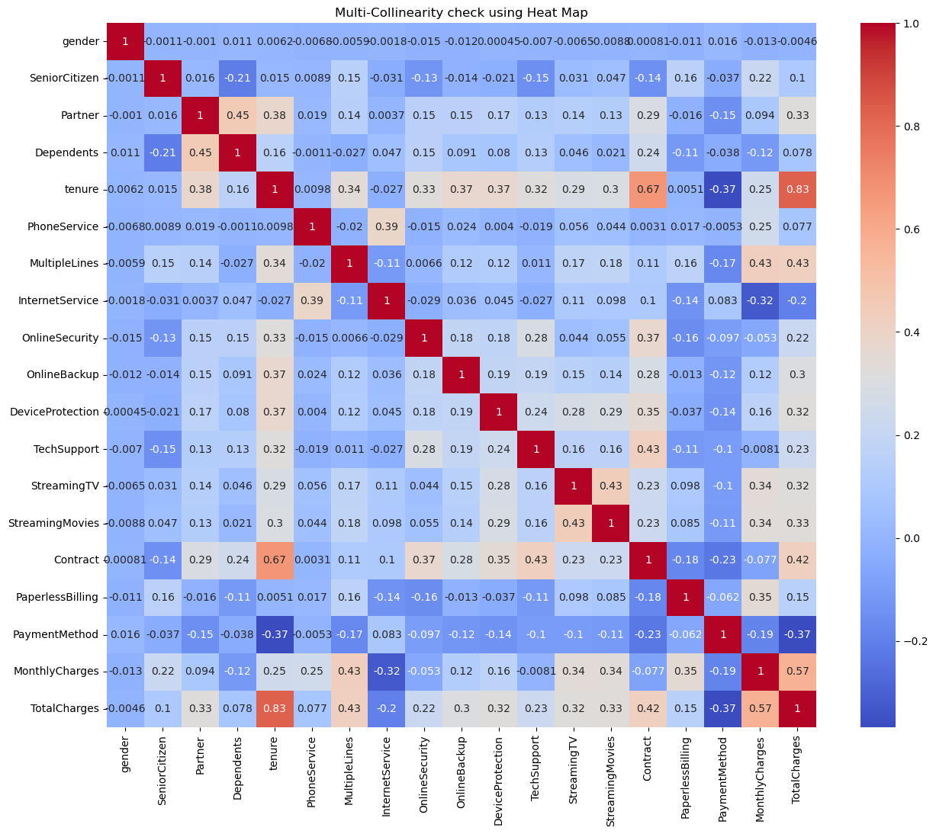

Trust me even on the Jupyter Notebook it looks all tiny due to the high number of columns. So, in such scenarios I majorly look at the colours to understand if there is any multicollinearity issue among the feature columns and if there is still any column that I can drop. But to clearly view the correlation between our label and feature columns I use a Bar Plot comparison and you can find it’s code here.

**Correlation check of features**

In the below Bar Plot we are able to clearly define the feature columns that are positively correlated with our label and the feature columns that are negatively correlated with our label.

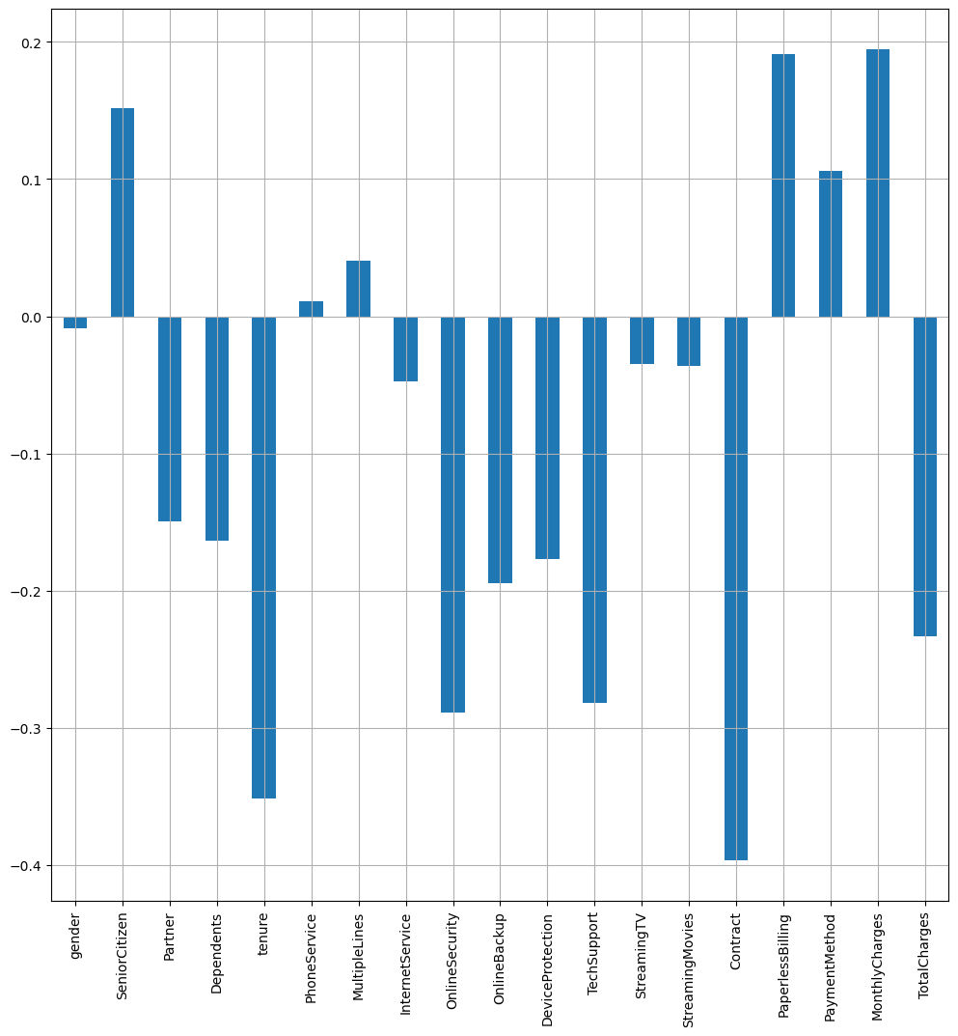

**Class Imbalance using SMOTE**

*#Importing Library*

**from** imblearn.over_sampling **import** SMOTE

over **=** SMOTE()

x, y **=** over**.**fit_resample(x, y)

y**.**value_counts()

0 5164

1 5164

Name: Churn, dtype: int64

*#Importing Library*

**from** imblearn.over_sampling **import** SMOTE

over **=** SMOTE()

x, y **=** over**.**fit_resample(x, y)

y**.**value_counts()

:

0 5164

1 5164

Name: Churn, dtype: int64

***##Scaling data using Standard Scaler***

scaler **=** StandardScaler()

x **=** pd**.**DataFrame(scaler**.**fit_transform(x), columns**=**x**.**columns)

x**.**head()

|  |  |  |  |  |  |  |  |  |  |  |  |  |  |  |  |  |  |  |  |
| --- | --- | --- | --- | --- | --- | --- | --- | --- | --- | --- | --- | --- | --- | --- | --- | --- | --- | --- | --- |
|  |  |  |  |  |  |  |  |  |  |  |  |  |  |  |  |  |  |  |  |
|  |  |  |  |  |  |  |  |  |  |  |  |  |  |  |  |  |  |  |  |
|  |  |  |  |  |  |  |  |  |  |  |  |  |  |  |  |  |  |  |  |
|  |  |  |  |  |  |  |  |  |  |  |  |  |  |  |  |  |  |  |  |
|  |  |  |  |  |  |  |  |  |  |  |  |  |  |  |  |  |  |  |  |

**5.      Building Machine Learning Models**  
  
In order to build a classification method I have imported the necessary libraries and created a function that contains all our machine learning model creation and its evaluation metrics steps. This makes our job easier since later on we just need to feed the model’s name and get the result without repeating/rewriting the same code again and again

***Importing necessary Libraries for Model building***

**from** sklearn.model_selection **import** train_test_split

**from** sklearn.linear_model **import** LogisticRegression

**from** sklearn.svm **import** SVC

**from** sklearn.tree **import** DecisionTreeClassifier

**from** sklearn.ensemble **import** RandomForestClassifier

**from** sklearn.neighbors **import** KNeighborsClassifier

**import** xgboost **as** xgb

**from** sklearn **import** metrics

**from** sklearn.metrics **import** classification_report

**from** sklearn.metrics **import** accuracy_score

**from** sklearn.model_selection **import** cross_val_score

**from** sklearn.model_selection **import** GridSearchCV

I would like to share a simple piece of code that allows us to choose a fitting random state for the machine learning models.  
  
Code:

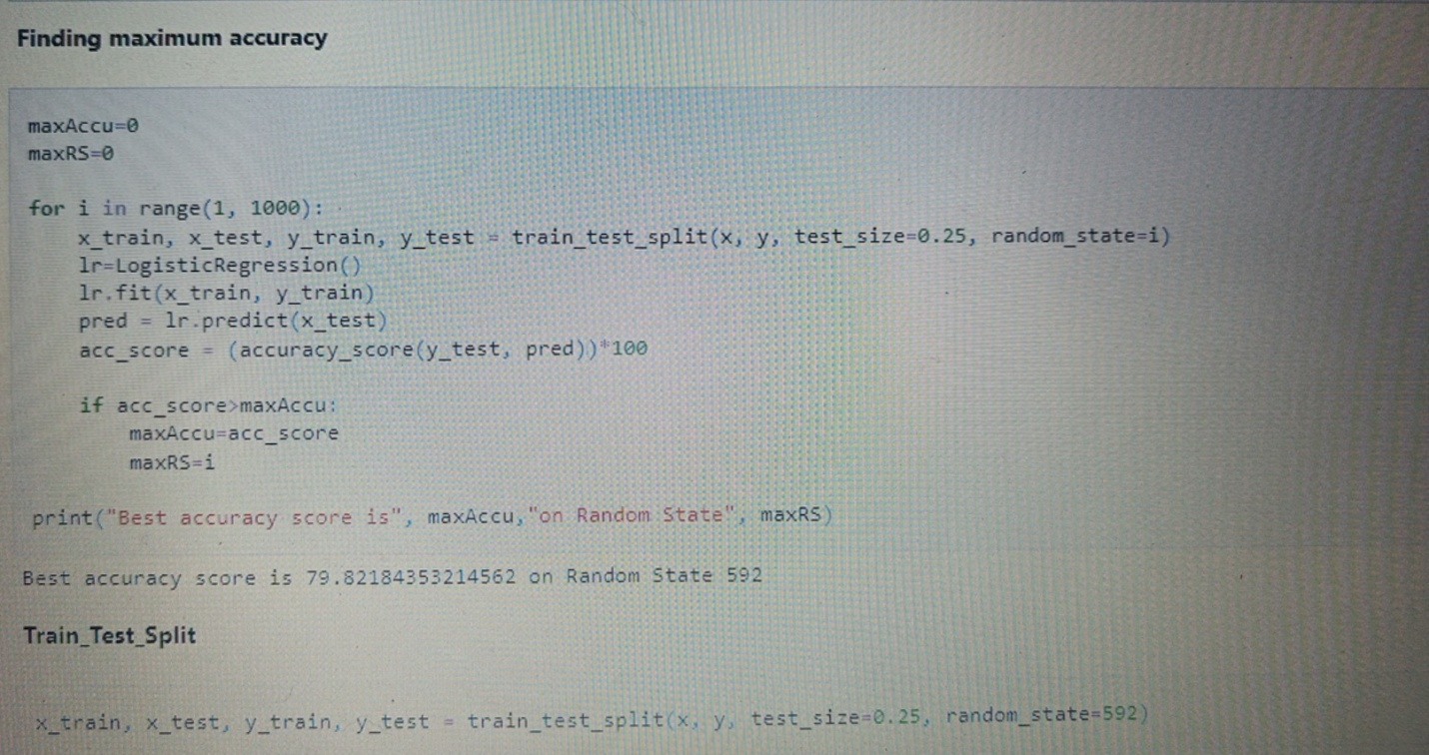  
Then I have used the train test split to bifurcate our entire data set into training data and testing data. Here I am using 75% data for training purpose and 25% data for testing purpose. Some people provide training and test data separately as well and hence it completely depends on you how you want to use this step.

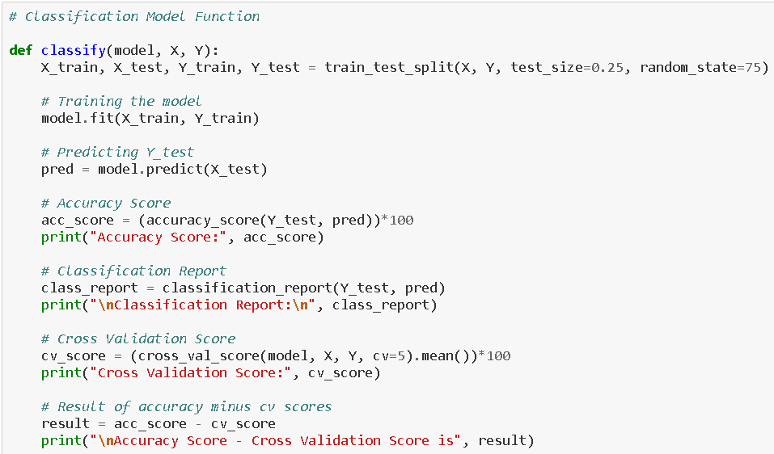

**Defining a function to print Accuracy_score,CV_Score,printing Classification_report and finally the result by deducting Accuracy score from CV score to choose the least difference model**

It is always advisable to build more than 5 machine learning models so that you can choose from the best performing model and then apply hyper parameter tuning to make it perform even better. I am going to use the RandomForest Classifier as my choice of classification model as I see it is doing better than the other models I used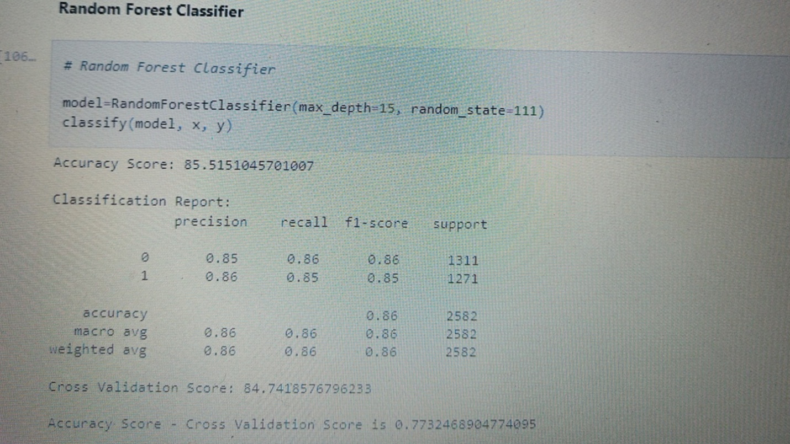.

**Hyperparameter Tuning**

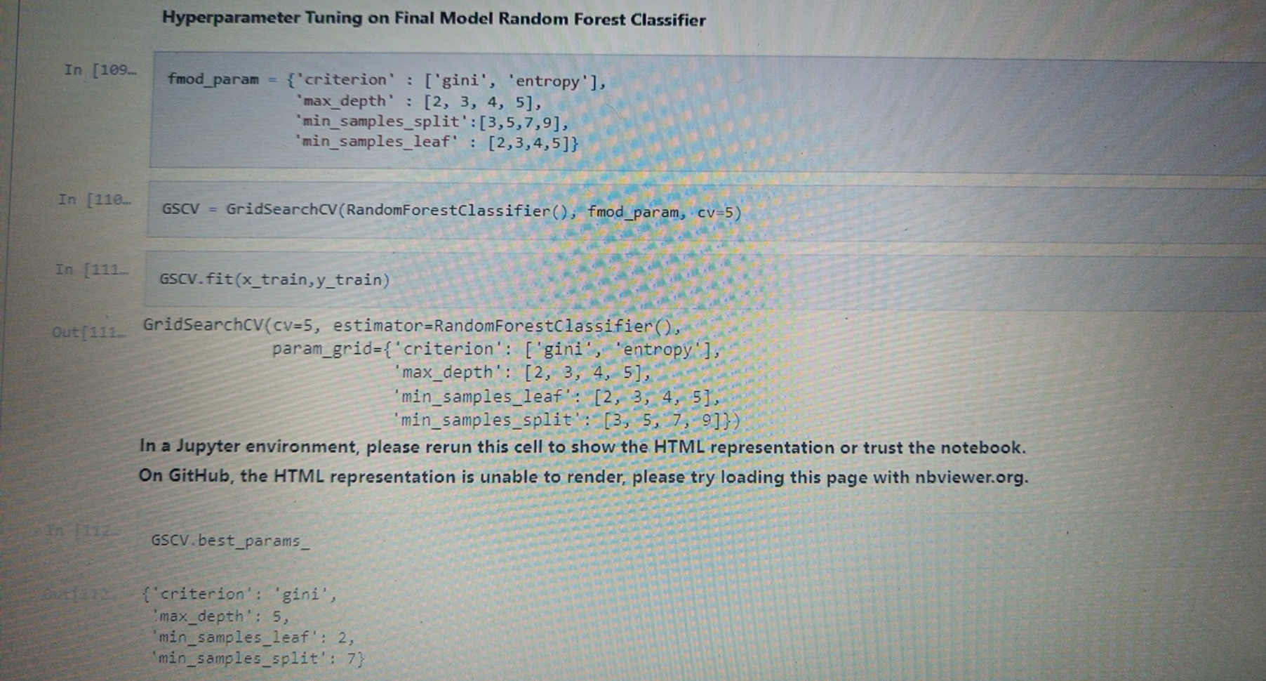

After applying the above steps to get the best parameters list, I simply have to plug it into my final model and receive the output of it. I have created an ROC curve plot and Confusion matrix for the final model.

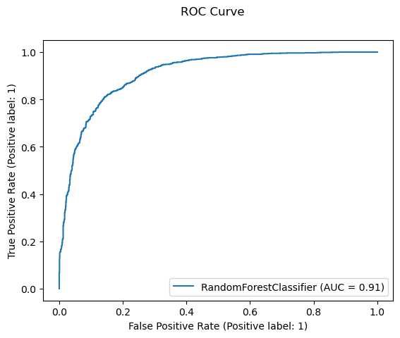

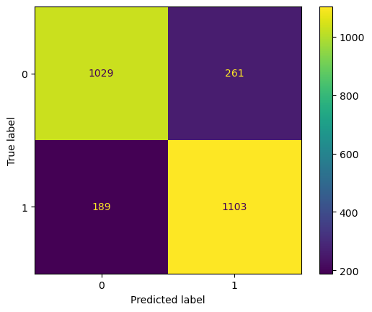

Once you have gone through all the previous steps and you are satisfied with outcome you can then save the final model using either joblib or pickle. I have used the joblib method to save and then load my model from the same saved filename.  
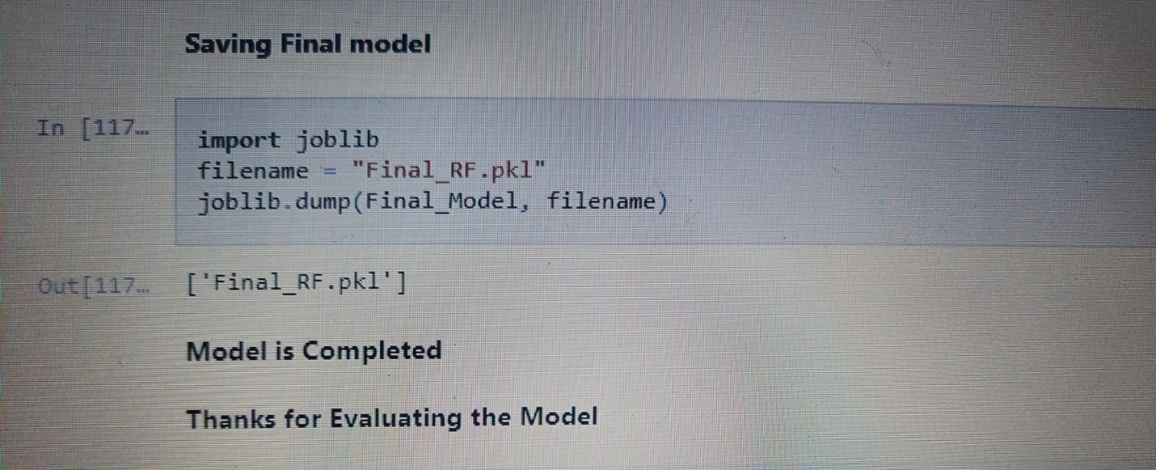**6.     Concluding Remarks**  
  
Kindly allow me to provide a quick recap on all the steps that we went through starting from understanding the Problem Definition then going through the Data Analysis and EDA processes. We went through the necessary Pre-processing Data steps before the final Building Machine Learning Models step came into picture.  
  
What I do is code my entire project on my own and then take a peek at the internet to look through other’s coding style for inspiration and understand if I can incorporate anything to improvise further on accuracy or beautify the visuals. However, I have seen many people doing the complete opposite whereupon they don’t practise or create their own unique coding style first and rather copy paste lines from the web and perform some sort of messy patch work and when asked to explain might not be capable of conveying functioning or usage of those code blocks.  
  
Before wrapping up my only advise to everyone is “No pain No gain” you will have to get your hands dirty with building your own code and trying out all the permutations and combinations. Create a self-made unique data story telling commandment list and follow it along with the standard project life cycle. Hope this at length article helps you in gaining the initial knowledge on building your first project from scratch.

**Disclaimer:** I am a newbie myself in this field with some accumulated knowledge over a year’s time studying Data Science and felt like since sharing is caring someone who’s stepping in now can benefit from my experience. I am also open to get some feedback from anyone that will help me in improving too! The content that I have written is solely my view of the project but it’s definitely inspired by others over the internet who have worked on similar projects before me.